EC 9130
Distribution Automation and Smart Grid

POWER SHARING METHOD FOR A DC MICROGRID
WEEKLY PROGRESS – 13TH WEEK

GROUP MEMBERS

- 2022/E/019
- 2022/E/020
- 2022/E/072
BASNAYAKE C.K
LIYANAGE B.P.H
GUNAWARDHANA K.H.M.I.K

INTRODUCTION
In this project, we are designing a DC microgrid system that allows multiple solar panels and batteries to work together efficiently to supply power to different loads. In a DC microgrid, several batteries and solar PV modules are connected in parallel to increase the total power capacity. However, without proper control, some batteries or PV modules may supply more power than others, which can lead to voltage instability, overloading, or underutilization of some sources. Our project focuses on sharing power properly among these sources while keeping the main DC bus voltage stable. To do this, we are using droop control and PI-PWM regulation for voltage and current management, and planning to implement state of charge (SoC) based control to balance battery usage. We are simulating the system in MATLAB/Simulink to check that the loads are supplied correctly, the batteries are managed efficiently, and the system remains stable under different conditions. This project will helps to understand how real DC microgrids work in places like EV charging stations, solar-powered buildings, or backup power systems.

OBJECTIVES:
The main objective of our project is to design and simulate a DC microgrid system that can share power effectively among multiple batteries and solar PV modules while keeping the DC bus voltage stable.
Therefore, we aim to,
- Maintain a stable DC bus voltage under varying load and solar generation conditions using PI-PWM voltage control.
- Implement balanced power sharing between parallel batteries and PV modules using droop control.
- Manage battery charging and discharging based on their state of charge (SoC) to prevent overloading and extend battery life.
- Implement adaptive droop control to dynamically adjust power contribution from each source based on real time conditions such as battery SoC and PV output.

PROGRESS SO FAR:
We have successfully implemented the solar panels and battery systems in our DC microgrid simulation. The solar panels generate power based on sunlight, and the system is designed so that the solar panels can charge the batteries whenever there is excess energy. We have also implemented battery charging and discharging management based on their state of charge (SoC), which make that no battery is overcharged or over discharged. This setup allows the batteries to share power efficiently according to their capacity while maintaining a stable DC bus voltage
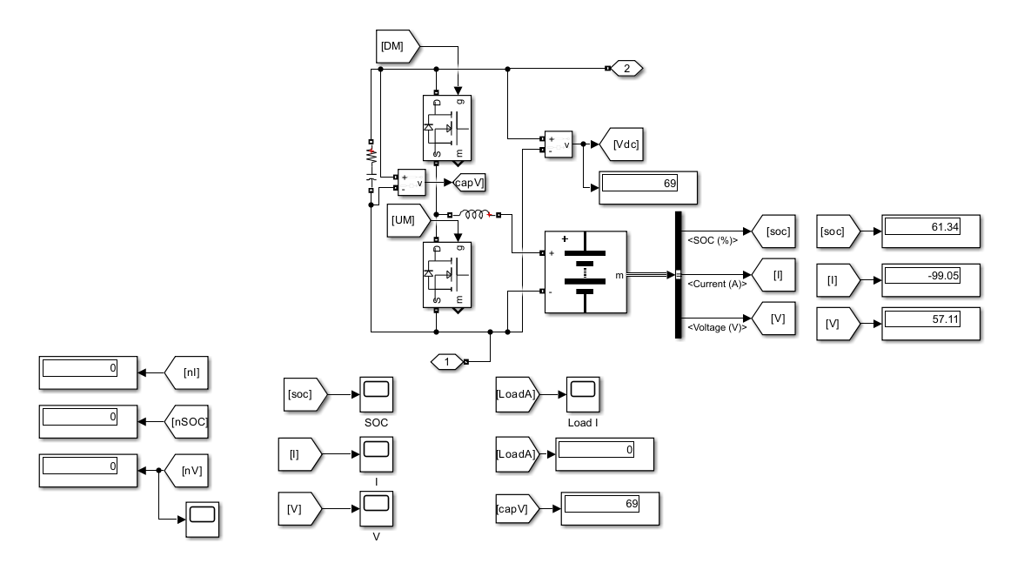
FIGURE 1: SOLAR CHARGING AND BATTERY SOC MANAGEMENT

AIM FOR 13TH WEEK:

- Connect solar panels and batteries to the sub bus system.
- Build a 2-unit DC microgrid system.
- Create a subsystem to compare battery parameters- SoC between the two units.
- Connect the sub bus to the main bus.

PROGRESS
- Connecting Solar Panels and Batteries to Sub Bus System
- Each unit has solar panel and battery connected through a bidirectional converter to its sub bus. The sub bus acts as the internal unit connection point, combining PV output and battery power before feeding the main bus. This responsible for stable voltage and proper routing of power from PV and battery to the main bus.

FIGURE 2: SINGLE UNIT WITH PV AND BATTERY CONNECTED TO SUB BUS

- Building a 2-Unit DC Microgrid System
- Both units were replicated identically and connected to the shared main bus, allowing power sharing between units. Modularity make that if one unit is underperforming, the other compensates automatically.

FIGURE 2: TWO UNIT DC MICROGRID CONNECTED TO MAIN BUS

- Create a subsystem to Compare Battery Parameters (SoC between the two units)
- Battery outputs were monitored for State of Charge (SoC), current, and voltage during simulation. Scenarios tested include,
- Both units generating full PV power
- One unit shaded
- Night-time (PV = 0, battery discharges)
- EMS ensures batteries discharge or charge appropriately, maintaining balanced SoC and protecting battery health.

FIGURE 3: BATTERY SOC COMPARISON FOR TWO UNITS

- Connecting Sub Bus to Main Bus
- Both sub buses from Unit 01 and Unit 02 were connected to the main bus, enabling centralized load supply and inter unit power sharing. The main bus voltage remained stable at constant voltage across all tested scenarios, confirming the proper operation of the combined system.

FIGURE 5: MAIN BUS VOLTAGE STABILITY FOR 2 UNIT SYSTEM
- Adaptive Droop Controller Implementation
- Adaptive droop control was implemented to dynamically adjust each unit’s droop coefficient based on real time SoC, PV output, and load. This allows units with higher available energy to contribute more to the main bus, while protecting units with low SoC.
- Simulation Figure: Include plots showing adaptive Rd values for both units and corresponding power contribution.
FIGURE 6: ADAPTIVE DROOP COEFFICIENT AND POWER SHARING BETWEEN UNITS

PLANNED WORK FOR NEXT WEEK:
- Develop and implement the adaptive droop controller in MATLAB/Simulink.
- Use automatic adjustment equations that calculate the droop coefficient based on each battery’s State of Charge (SoC) and PV output.
- Test the adaptive droop control to ensure balanced power sharing, protecting batteries with low SoC while allowing units with higher energy to contribute more.

CONCLUSION:
Up to the 13th week, we have successfully designed and simulated a two unit DC microgrid system with solar panels and batteries connected through sub buses to a shared main bus. The system is capable of monitoring and comparing battery parameters (SoC, current, voltage) and PV power output for both units. The sub bus and main bus connections maintain stable voltage and allow basic automatic power sharing between the two units. The system is now ready for the implementation of the adaptive droop controller in the next week, which will dynamically adjust the droop coefficient based on battery SoC and PV output to further optimize power sharing and protect battery health.

